AgID Cloud Italia Qualification Compliance for Log360
Tagline: Support security requirements under AgID Cloud Italia with cloud monitoring from Log360.

Overview
The AgID Cloud Italia Qualification Compliance extension for Log360 helps Italian public administrations and cloud service providers seeking or maintaining AgID Cloud Italia qualification meet the security monitoring, logging, and incident management requirements of the Italian cloud qualification framework.
Log360 collects and correlates logs from cloud infrastructure, identity systems, applications, and network devices, providing security teams with continuous visibility into events affecting public sector cloud services. Compliance teams can monitor control effectiveness and generate audit-grade evidence for ACN and AgID qualification reviews.

Key Features
- Generate predefined compliance reports covering AgID Cloud Italia security requirements including access monitoring, cloud infrastructure events, and incident detection.
- Monitor cloud workload activity, user access patterns, and configuration changes across Italian public administration cloud environments in real time.
- Leverage CASB capabilities in Log360 to gain full visibility into cloud application usage and detect shadow IT in public sector environments.
- Export qualification evidence in PDF and CSV formats for AgID assessments and internal public sector IT governance reviews.
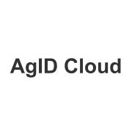
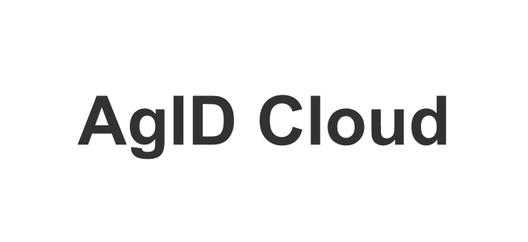

Screenshots
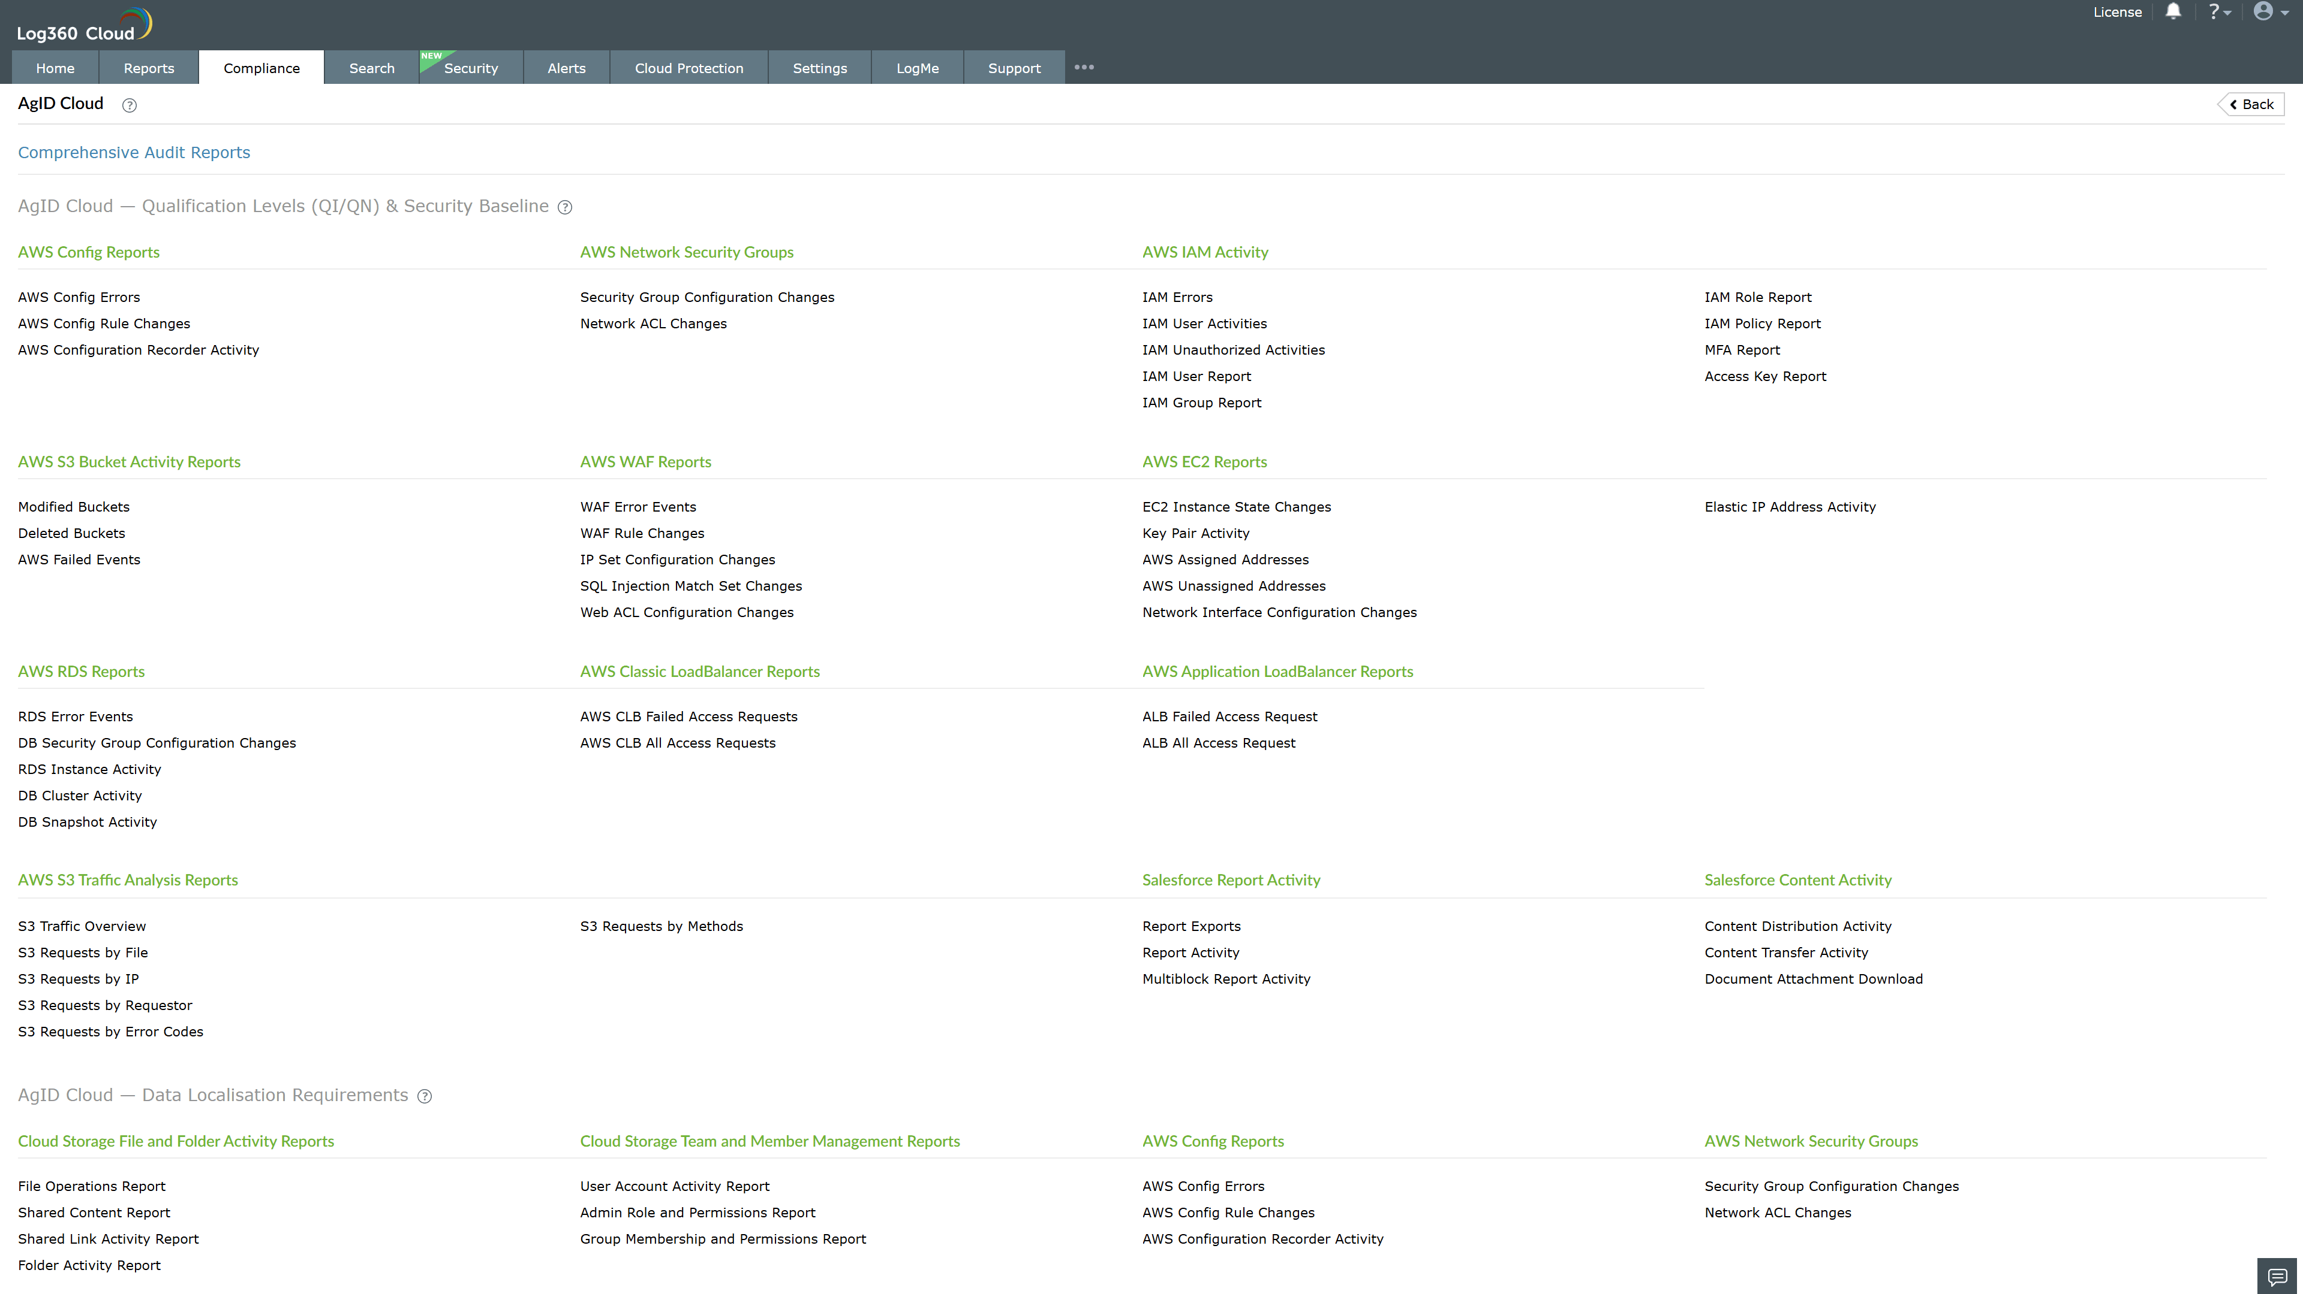
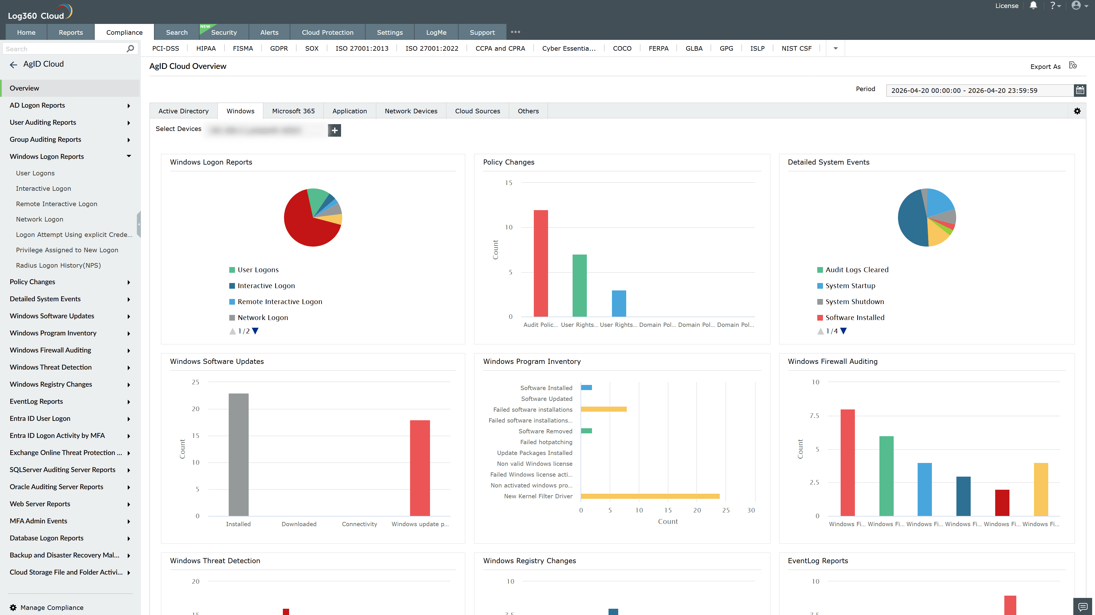
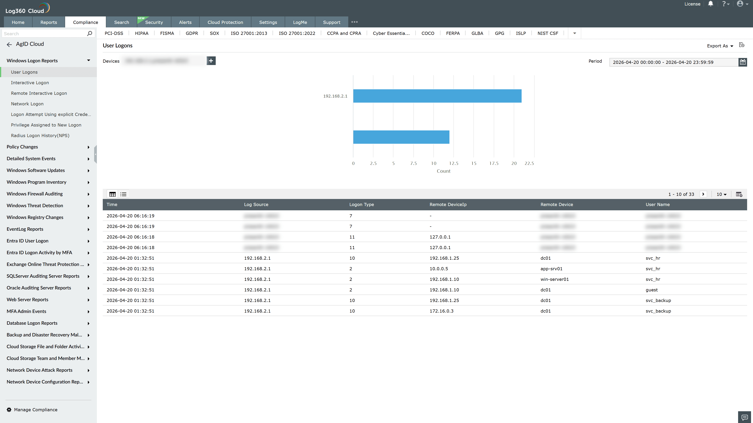
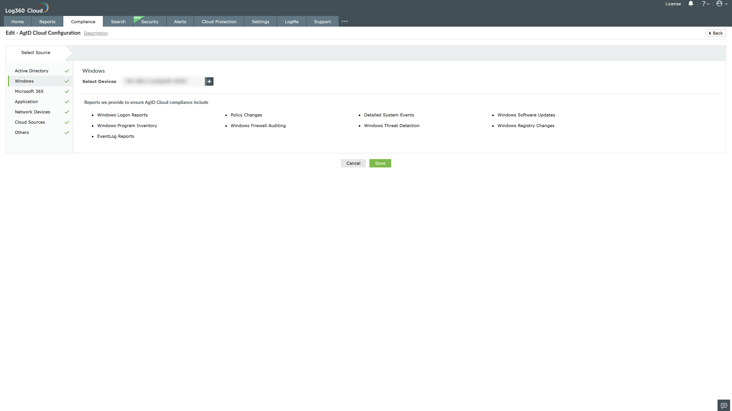

Valid Submission : Yes
Supported Editions : Free, Basic, Standard, Professional, MSSP
Help Document : https://www.manageengine.com/log-management/help/integrations/compliance-extensions.html
Help Video : Not provided
Tags : Log360, Compliance, Privacy monitoring, Data privacy, Regulatory compliance
Supported DCs : US, IN, JP, CA, AU, UK and EU
Privacy Policy:
Terms of Service:
Release Notes:
Predefined reports for the AgID Cloud Italia Qualification Compliance

